CNC Machining China: Precision Manufacturing Excellence
When it comes to precision manufacturing, few places on Earth can compete with the technological prowess and cost-effectiveness of CNC machining China. In today's global marketplace, CNC machining in China has taken center stage as a powerhouse of innovation and quality. This article explores the dynamic world of CNC machining in China, revealing how it has become a game-changer for industries worldwide.

The CNC Machining China Advantage
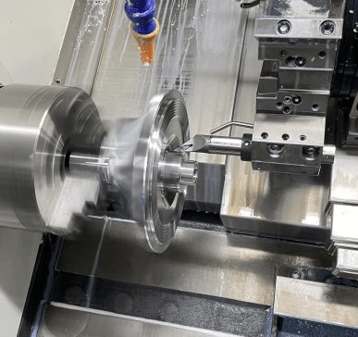
CNC machining, short for Computer Numerical Control machining, is a cutting-edge manufacturing method that relies on computerized controls and advanced machinery to produce intricate and precise components. China's CNC machining sector has rapidly evolved, earning a reputation for being among the world's best. Let's delve into the reasons behind the remarkable success of CNC machining in China.

1. Unmatched Precision and Accuracy
At the heart of CNC machining in China lies an unwavering commitment to precision and accuracy. Advanced technology, combined with a skilled and dedicated workforce, ensures that even the most intricate designs are executed with unparalleled precision. This level of detail is indispensable in industries such as aerospace, automotive, medical, and electronics, where tolerances are exceedingly tight.
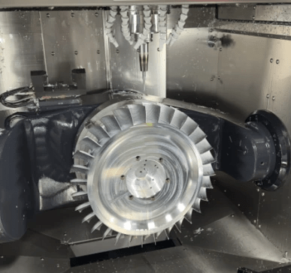

2. Cost-Efficiency without Compromise
One of the key attractions of CNC machining in China is its ability to deliver high-quality products at a fraction of the cost compared to many other countries. Competitive labor rates, efficient manufacturing processes, and economies of scale mean that businesses can reap substantial cost savings when choosing China as their CNC machining destination.

3. Cutting-Edge Technology
Chinese CNC machining facilities continuously invest in state-of-the-art equipment and technology, ensuring they remain at the forefront of innovation. This ongoing commitment to technological advancement translates into higher product quality, efficiency, and an enhanced ability to handle even the most complex projects.

4. Scalability and Versatility
Whether you require a single prototype or a large batch of components, China's CNC machining industry can meet your needs with remarkable versatility. This scalability is crucial for businesses with diverse production requirements, allowing them to adapt quickly to market demands.

Considerations for CNC Machining in China
While the advantages of CNC machining in China are compelling, there are several considerations when selecting a manufacturing partner:
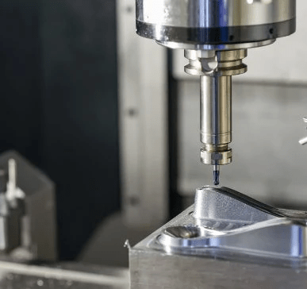

1. Effective Communication
Effective communication is vital when collaborating with overseas manufacturers. Ensuring that your specifications and requirements are clearly understood can prevent misunderstandings and project delays. Many Chinese machining companies employ English-speaking teams to facilitate communication.

2. Quality Assurance
Select a manufacturer with a strong track record in quality control and assurance. Requesting samples and, if possible, visiting the facility can provide valuable insights into the manufacturer's quality standards.

3. Lead Times and Shipping
Bear in mind that international shipping and customs processes may add time to your project. Planning for lead times and shipping can help you manage production schedules effectively.

4. Intellectual Property Protection
Safeguarding your intellectual property rights is essential when outsourcing to China. Partnering with a reputable manufacturer with a history of respecting intellectual property can help protect your innovations and designs.

Conclusion
CNC machining China represents a compelling choice for businesses seeking precision, cost-efficiency, and technological excellence in their manufacturing processes. With its unwavering dedication to quality, state-of-the-art technology, and a highly skilled workforce, CNC machining in China stands at the forefront of global manufacturing.
By carefully considering these factors and working with trusted CNC machining companies in China, businesses can harness the full potential of precise and cost-effective manufacturing, positioning themselves for success in the highly competitive global marketplace. CNC machining in China is more than just a service; it's a gateway to excellence and innovation in manufacturing.

